You need to have one file per Component and that means in React project you will end up with dozens or hundreds of files because in React project you'll have dozens or hundreds of Components in the end and that's absolutely normal.

To organize our source code in the source folder, I'll add the Components folder which will hold all these Components source files. I will not move App.js file in there because this App Component will be a special kind of Component regarding its role in the application. It will be our root Component, which means it's the main Component being rendered in our index.js.

And other Components will be either nested inside of App.js or nested inside of other Components therefore, we will build a Component Tree. Big application therefore can result in quite big Component Trees, where only the top most Component is rendered directly into the HTML page, with help of that ReactDOM.render() instruction.

All the other Components will not be rendered with this instruction but instead will be used as regular HTML elements inside of our HTML code, inside of our Components.

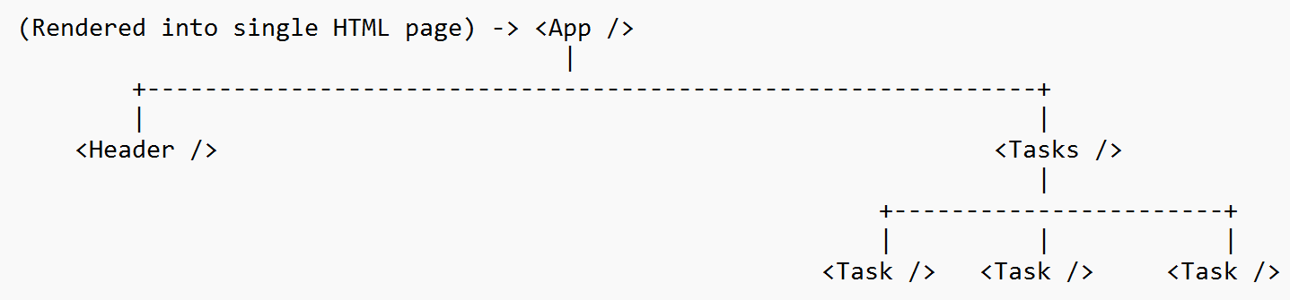

Inside of the Components folder, I'll add a new file which I will name ExpenseItem.js. About the filename, we are generally free to name it however we want, but it's a common convention in React applications to follow camel case and also file name should tell us which kind of logic will be inside of that file.

**How to write a Component in React?**

**IMPORTANT:** A Component in React is just a JavaScript function and it returns the JSX code. Therefore, if we want to create an ExpenseItem Component here, we add the function keyword, give it any name of our choice, though again, the convention is to repeat the file name here just without the extension and then in here we return the HTML code.

After writing the custom Component ExpenseItem you can import it in the App.js file and then in there you can use it as an HTML tag. The key difference to the built in HTML elements just is that it's not starting with a lowercase character, but with an uppercase character. Custom Components must start with an uppercase character so that the React is able to detect it.

We have to use the name which we use in the import as a name in the call, because that's how this connection is established. This tells React that we want to use this Component which is imported under this name from the ExpenseItem file.